Test1:

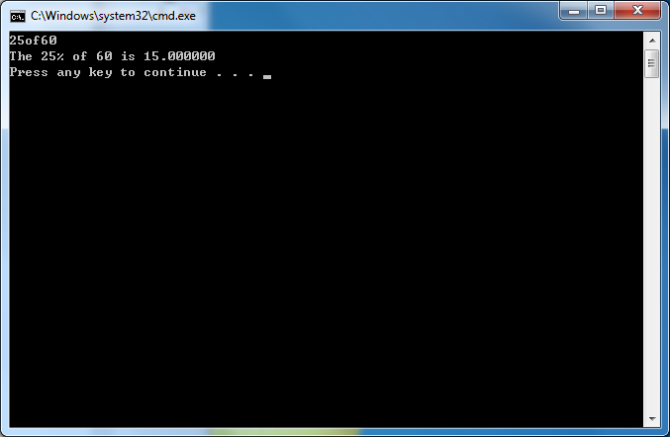

Code:

#include<stdio.h>

int main()

{

int percentage,x;

char ch1,ch2;

scanf("%d%c%c%d",&percentage,&ch1,&ch2,&x);

printf("The %d%% %c%c %d is %f\n",percentage,ch1,ch2,x,1.0\*x\*percentage/100);

return 0;

}

Input:25of60

According to the function, it will scan each character you input, and from the code wo know that ("%d%c%c%d"… it allows you to input 2 intergers and 2 characters. So if we input” 25of60”, function will scan them all and output the correct answer.

Test 2:

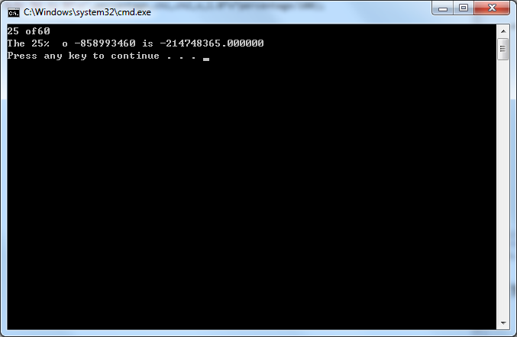

Code:

#include<stdio.h>

int main()

{

int percentage,x;

char ch1,ch2;

scanf("%d%c%c%d",&percentage,&ch1,&ch2,&x);

printf("The %d%% %c%c %d is %f\n",percentage,ch1,ch2,x,1.0\*x\*percentage/100);

return 0;

}

Input:25 of60

We know that the ‘ ’is a kind of char ,so if we insert a space between 25 and of, the scanf will take the ‘ ’ as a char. As a result ,we cannot get “of” and the “f”

take the place of the number-------- it will cause the wrong number input ,so we output a disappointing output.

Test 3:

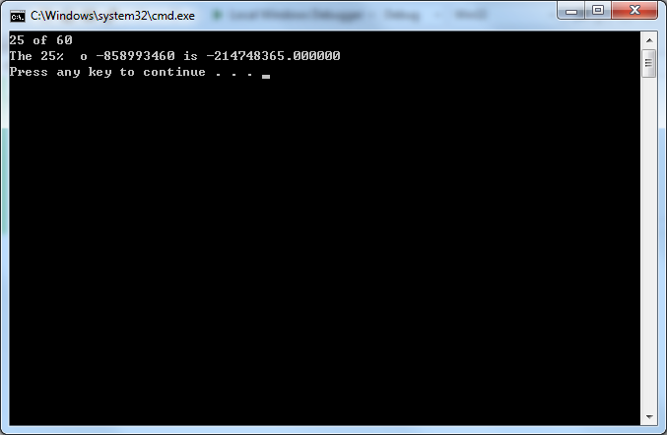

Code:

#include<stdio.h>

int main()

{

int percentage,x;

char ch1,ch2;

scanf("%d%c%c%d",&percentage,&ch1,&ch2,&x);

printf("The %d%% %c%c %d is %f\n",percentage,ch1,ch2,x,1.0\*x\*percentage/100);

return 0;

}

Input:25 of 60

We know that the ‘ ’is a kind of char ,so if we insert a space between 25 and of, the scanf will take the ‘ ’ as a char. As a result ,we cannot get “of” and the “f”

take the place of the number-------- it will cause the wrong number input ,so we output a disappointing output.